Create Jumpbox VM:

Open your Azure portal and search for "virtual machines."

Use the **+ Add** button or the **Create virtual machine** button to create a new VM.

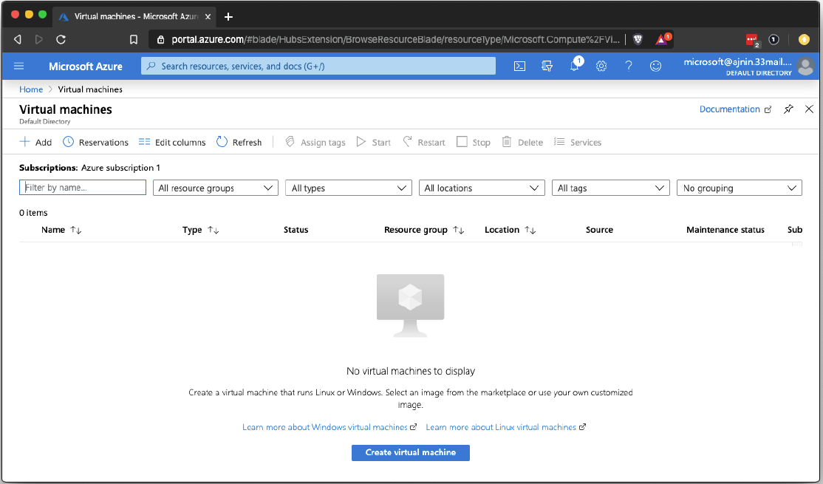

Use the following settings for this VM:

Resource group: Choose the same resource group that you created for the Red Team.

* Virtual machine name: Use the name "Jump Box Provisioner."
* Region: Use the same region that you used for your other resources.
* Note that availability of VM's in Azure could cause you to change the region where
* your VM's are created.
* The goal is to create 3 machines in the same resource group attached to the same security group. If you cannot add 3 machines to the resource group and security group that you have, a new resource group and security group may need to be created in another region.

Availability options: We will use this setting for other machines. For our jump box, we will leave this on the default setting.

Image: Choose the Ubuntu Server 18.04 option.

Choose the VM option that has:

* Whose offering is Standard - B1s
* 1 CPU
* 1 RAM

For SSH, use the following settings:

* Authentication type: SSH public key.
* Username: Create any username you like.
* SSH public key: Paste the public key string that you copied earlier.
* Public inbound ports: Ignore this setting. It will be overwritten when you choose your security group.

For SSH, use the following settings:

* Authentication type: SSH public key.
* Username: Create any username you like.
* SSH public key: Paste the public key string that you copied earlier.
* Public inbound ports: Ignore this setting. It will be overwritten when you choose your

security group.

* Select inbound ports: Ignore this setting. It will be overwritten when you choose your

security group.

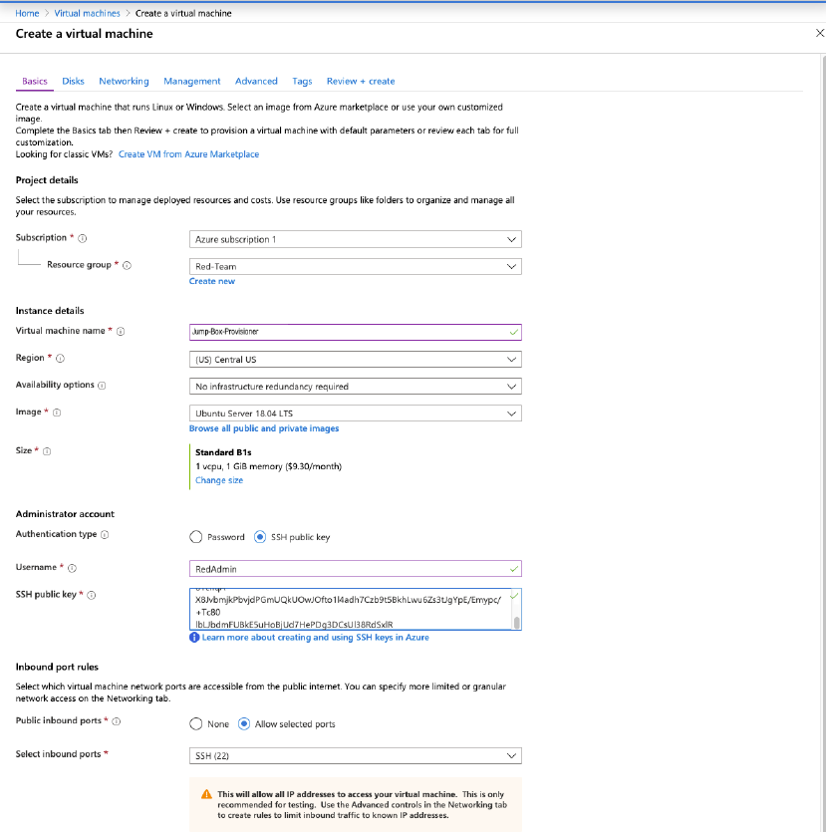

Move to the **Networking** tab and set the following settings:

* Virtual network: Choose the VNet you created for the Red Team.
* Subnet: Choose the subnet that you created earlier.
* Public IP: Choose Create new and choose Static under Assignment in the side
* panel. Give the IP Address a unique name.

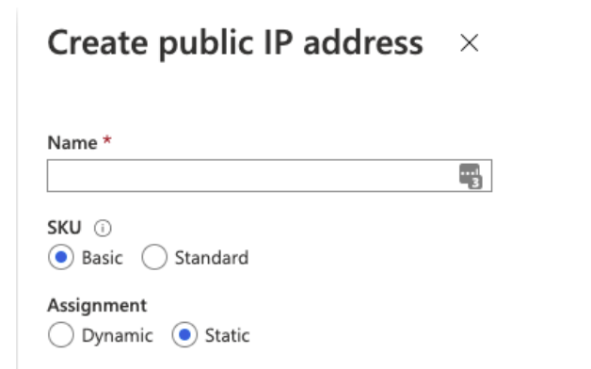

* NIC network security group: Choose the Advanced option so we can specify our custom

security group.

* Configure network security group: Choose your Red Team network security group.
* Accelerated networking: Keep as the default setting (Off).
* In the Networking settings, take note of the VM URL. You may use it later.
* Load balancing: Keep as the default setting (No).

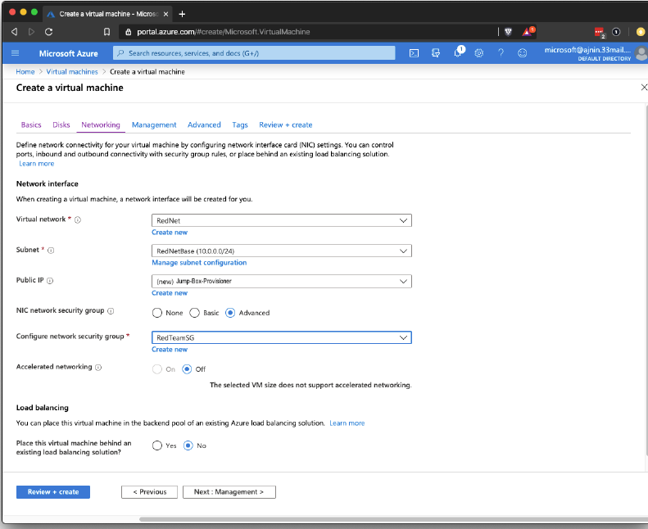

Click on **Review + create**.

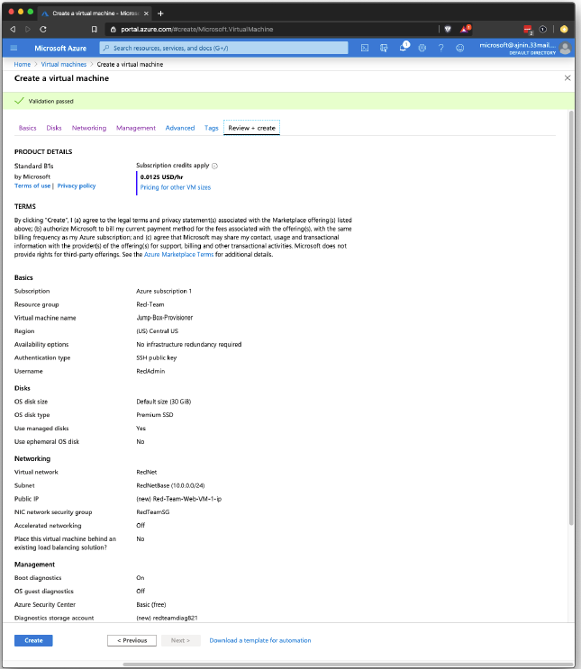

Finalize all your settings and create the VM by clicking on the Create button.

**VM's 2 and 3 - Web VM's:**

Create 2 more new VMs. Keep the following in mind when configuring these VM's: - Each VM

should be named "Web-1" and "Web-2"

* These VM's need to be in the same resource group you are using for all other resources.
* The VM's should be located in the same region as your resource group and security group.
* Note that availability of VM's in Azure could cause you to change the region where

your VM's are created.

* The goal is to create 3 machines in the same resource group attached to the same

security group. If you cannot add 3 machines to the resource group and security group

that you have, a new resource group and security group may need to be created in

another region.

* The administrative username should make sense for this scenario. You should use the

same admin name for all 3 machines. Make sure to take a note of this name as you will

need it to login later.

* You will need to create a new SSH key for remote connections.
  + **Note:** Windows users should use GitBash to create ssh keys and ssh connections.
* Choose the VM option that has:
  + Whose offering is Standard - B1ms
  + 1 CPU
  + 2 RAM

Note: These web machines should have 2 GB of RAM and the Jump-Box only needs 1 GB. All 3

machines should only have 1 vCPU because the free Azure account only allows 4 vCPU's in

total per region.

Important: Make sure both of these VM's are in the same availability Set. Under Availability

Options, select 'Availability Set'. Click on 'Create New' under the Availability set. Give it an

appropriate name. After creating it on the first VM, choose it for the second VM.

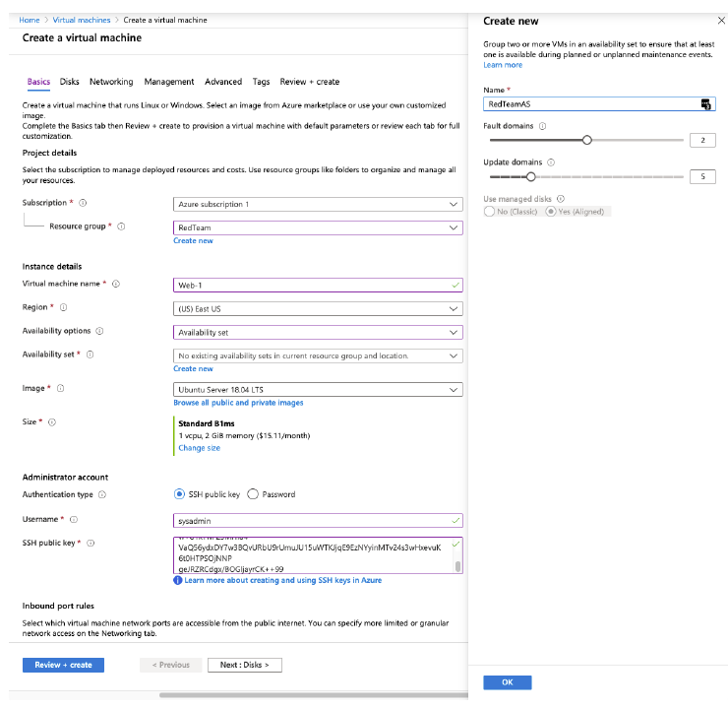

In the Networking tab and set the following settings:

* Virtual network: Choose the VNet you created for the Red Team.
* Subnet: Choose the subnet that you created earlier.
* Public IP: NONE! Make sure these web VM's do not have a public IP address.

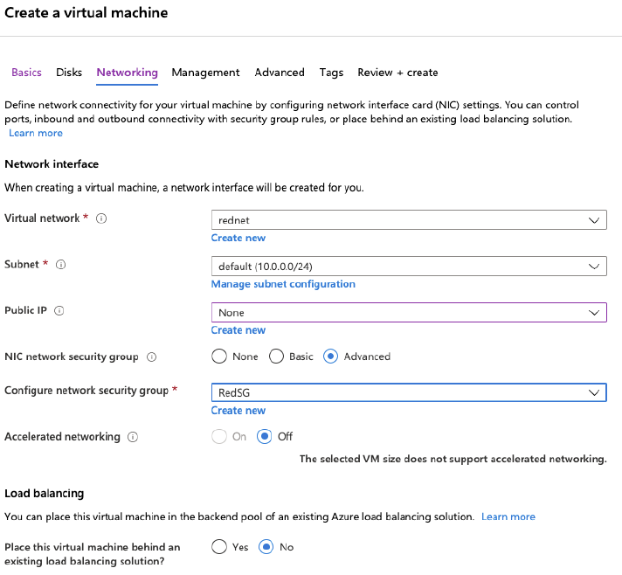

* NIC network security group: Choose the Advanced option so we can specify our custom
* security group.
* Configure network security group: Choose your Red Team network security group.
* Accelerated networking: Keep as the default setting (Off).
* In the Networking settings, take note of the VM URL. You may use it later.
* Load balancing: Keep as the default setting (No).

**NOTE:** Notice that these machines will not be accessible at this time because our security group

is blocking all traffic. We will configure access to these machines in a later activity.

Below is an example of how to create/view ssh keys- note this key must be generated from the local machine:

cyber@2Us-MacBook-Pro ~ % ssh-keygen

Generating public/private rsa key pair.

Enter file in which to save the key (/Users/cyber/.ssh/id_rsa):

Enter passphrase (empty for no passphrase):

Enter same passphrase again:

Your identification has been saved in id_rsa.

Your public key has been saved in id_rsa.pub.

The key fingerprint is:

SHA256:r3aBFU50/5iQbbzhqXY+fOIfivRFdMFt37AvLJifC/0 cyber@2Us-MacBook-

Pro.local

The randomart image is:

+---[RSA 2048]----+

| .. . ...|

| o. =..+|

| o .o *=+|

| o +oB+|

| So o .*o.|

| ..+...+ .|

| o+++.+ |

| ..oo=+* o|

| ... ..=E=.|

+----[SHA256]-----+

Run cat ~/.ssh/id_rsa.pub to display your id_rsa.pub key:

cyber@2Us-MacBook-Pro ~ % cat ~/.ssh/id_rsa.pub

ssh-rsa AAAAB3NzaC1yc2EAAAADAQABAAABAQDGG6dBJ6ibhgM09U+kn/5NE7cGc4CNH

WXein0f+MciKElDalf76nVgFvJQEIImMhAGrtRRJDAd6itlPyBpurSyNOByU6LX7Gl6Df

GQKzQns6+n9BheiVLLY9dtodp8oAXdVEGles5EslflPrTrjijVZa9lxGe34DtrjijExWM

6hBb0KvwlkU4worPblINx+ghDv+3pdrkUXMsQAht/fLdtP/EBwgSXKYCu/

ssh [sysadmin@13.77.182.22](mailto:sysadmin@13.77.182.22) to jumpbox